**HON ASSESSMENT SUBMISSION DOCUMENT**

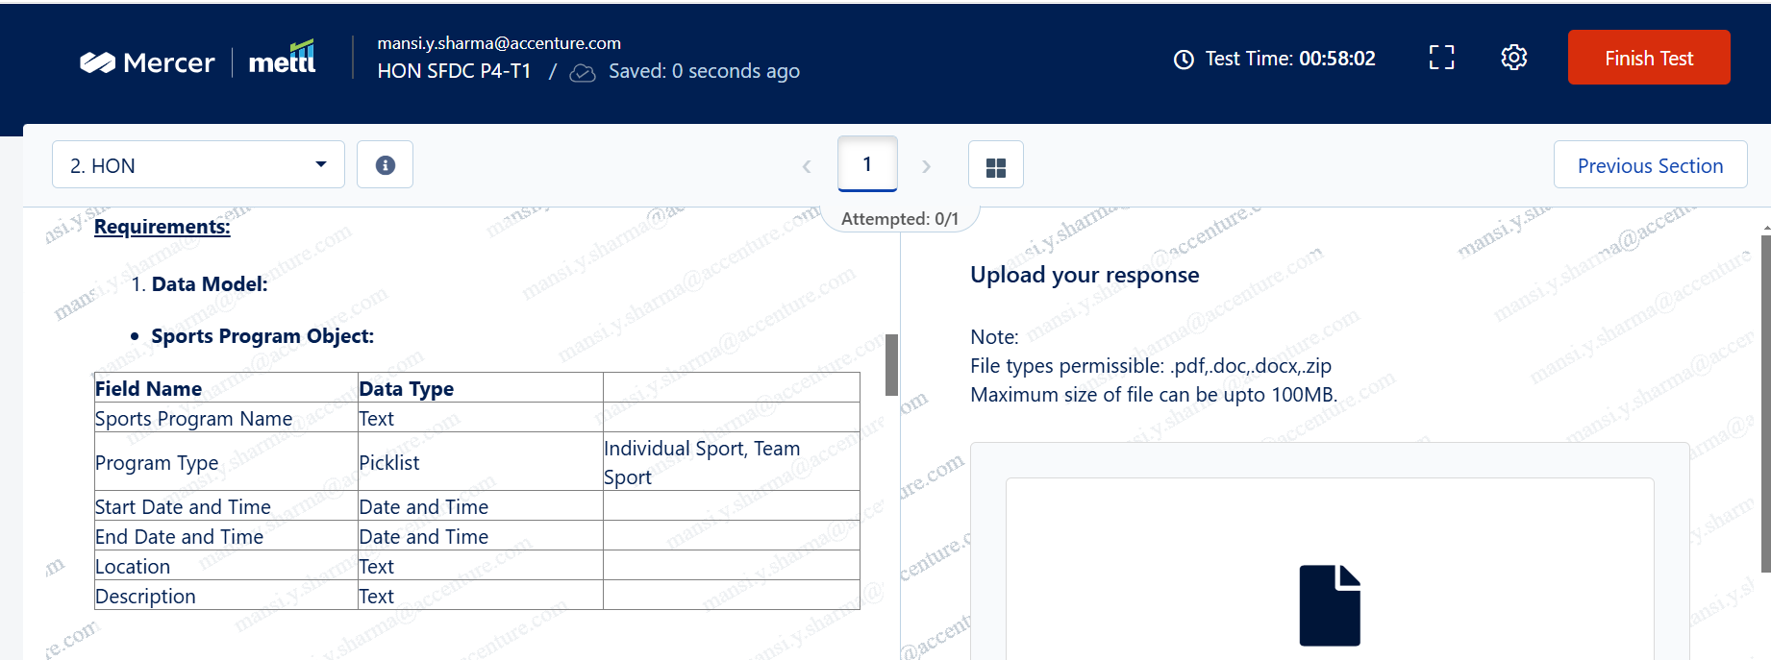

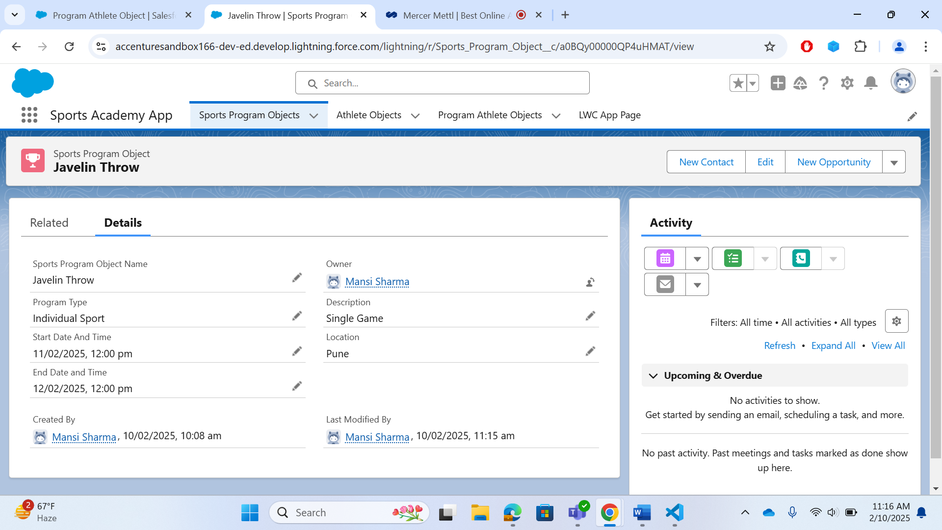

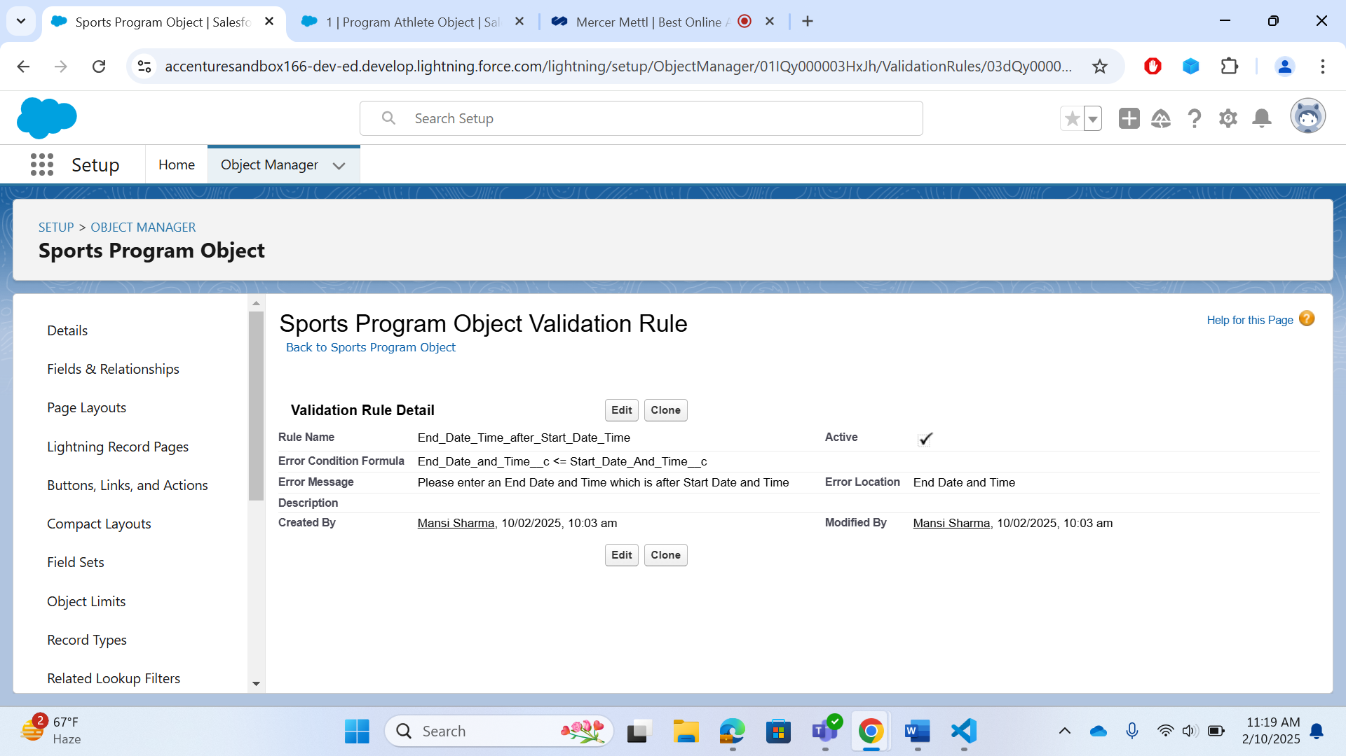

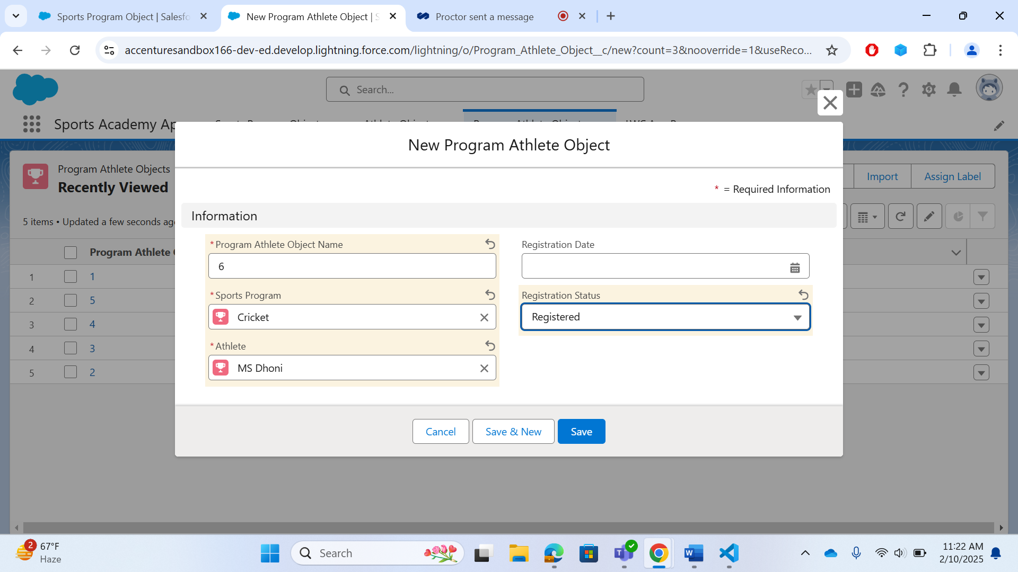

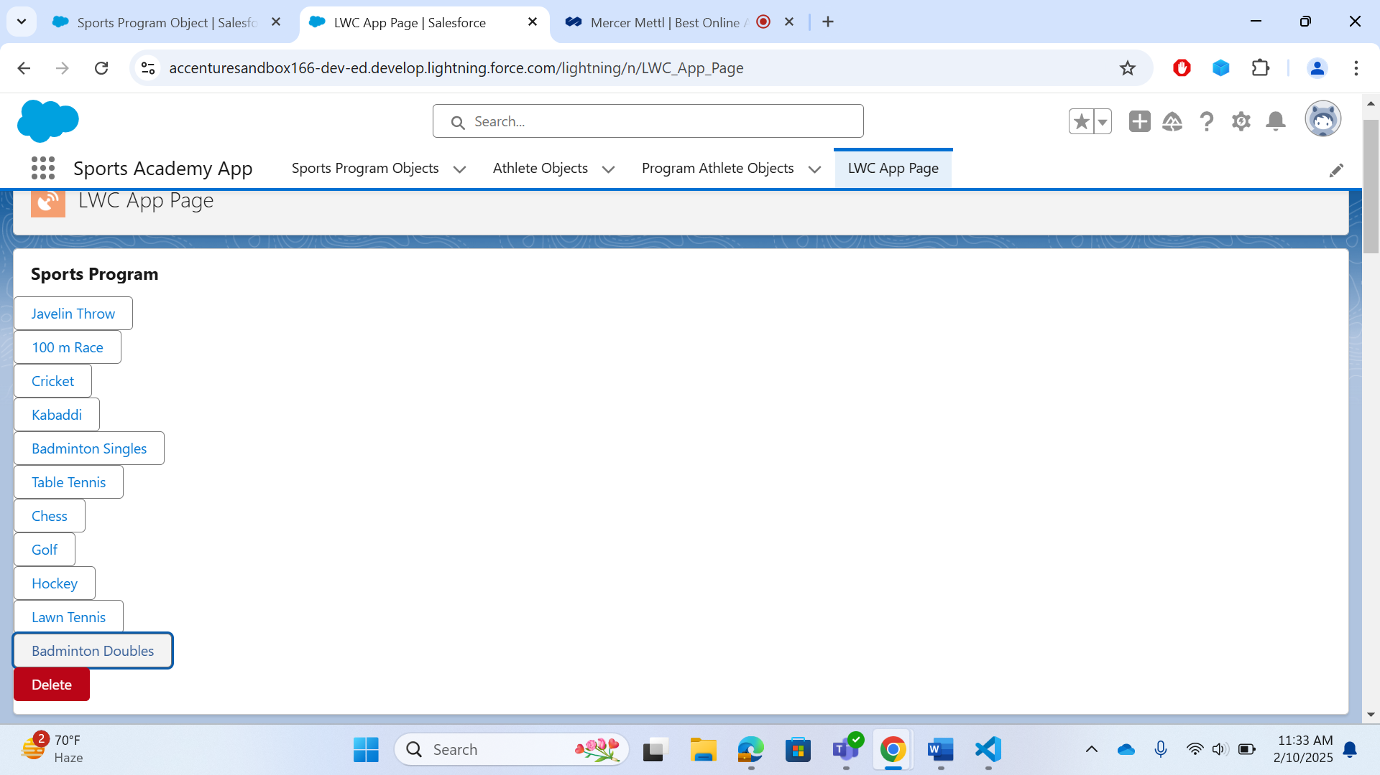

**SUBMISSION BY :**

**MANSI SHARMA**

**EMP ID : 13941823**